SOUTH EAST TECHNOLOGICAL UNIVERSITY

Library Management System Ontology
Student Number: 20115511
16 April 2026

Table of Contents
1. Introduction 4
2. Class Hierarchy 4
3. Object Properties 5
5. Individuals 7
6. Extension Tasks 9
6.1 Disjointness 9
6.2 Cardinality Restriction 9
6.3 Realistic Class Added – Loan 9
7. Reasoning 10
8. SPARQL Queries & Results 11
Query 1 List All Members 11
Query 2 Member Names & Membership IDs 11
Query 3 Which Member Borrowed Which Book 12
Query 4 Books & Their Authors 12
Query 5 Loans Linked to Members & Books 12
9. Linked Data – GitHub Hosting 14

Figure 1 Showing the class Hierarchy 4
Figure 2 Object Properties of Library 5
Figure 3 Data Properties of Library 6
Figure 4 Individuals by class 8
Figure 5 Disjointness Rules of library 9
Figure 6 Cardinality Restriction on Loan 9
Figure 7 Reasoner Consistency Check of Library 10
Figure 8 Results of ALL members query 11
Figure 9 Results of Member Names & IDs Query 11
Figure 10 Members & Books Borrowed Query Results 12
Figure 11 Results of Query Books & Authors 12
Figure 12 Loans linked to Members & Books query Results 12

1. Introduction
This report provides information about Library Management System Ontology that was created with the help of Protégé for the CA2 project. It is a library domain ontology describing members, librarians, books, authors, loans, and a library itself using OWL 2 and containing property assertions, disjointness axioms, a cardinality restriction, HermiT reasoning, and five SPARQL queries.

2. Class Hierarchy
Seven classes were defined. Person acts as the shared superclass for Member and Librarian:
- Person Member (subclass), Librarian (subclass)
- Library the central institution managing members and librarians
- Book a physical or digital resource available for borrowing
- Author the creator of one or more books
- Loan a borrowing transaction linking a member to a book
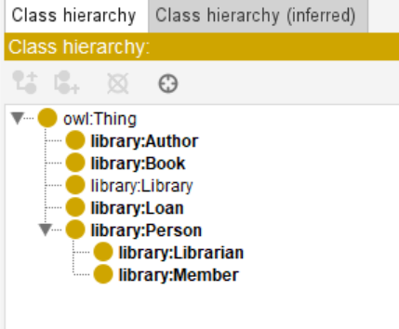
Figure 1 Showing the class Hierarchy

3. Object Properties
Six object properties define relationships between classes. Domain and range were entered as plain class names in Protégé:
Table 1 Object Properties
Object Property | Domain | Range
hasMember | Library | Member
hasLibrarian | Library | Librarian
borrowsBook | Member | Book
hasLoan | Member | Loan
loanForBook | Loan | Book
writtenBy | Book | Author

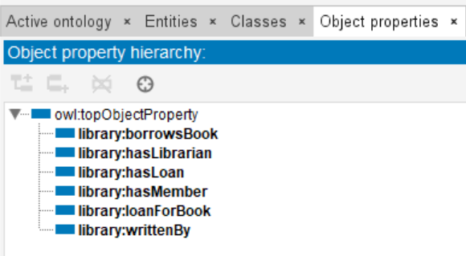
Figure 2 Object Properties of Library

4. Data Properties
Seven data properties store literal values on individuals with appropriate XSD datatypes:
Table 2 Data Properties of Library
Data Property | Domain | Datatype
personName | Person | xsd:string
membershipID | Member | xsd:string
bookTitle | Book | xsd:string
isbn | Book | xsd:string
authorName | Author | xsd:string
loanDate | Loan | xsd:dateTime
dueDate | Loan | xsd:dateTime

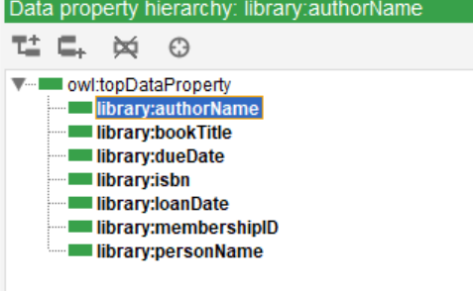
Figure 3 Data Properties of Library

5. Individuals
Twelve individuals were created across all classes. All values are sourced directly from the RDF file.
Members
- Member_Gayatri – personName: Gayatri Patchigolla | membershipID: M001 | borrowsBook: Book_AI101 | hasLoan: Loan_001
- Member_Sai – personName: Sai Guru | membershipID: M002 | borrowsBook: Book_DB202 | hasLoan: Loan_002
Librarian
- Librarian_Sneha – personName: Sneha Iyer
Library
- CentralLibrary – hasMember: Member_Gayatri, Member_Sai | hasLibrarian: Librarian_Sneha
Books
- Book_AI101 – bookTitle: Introduction to Artificial Intelligence | isbn: 9780136042594 | writtenBy: Author_Russell
- Book_DB202 – bookTitle: Fundamentals of Database Systems | isbn: 9780133970777 | writtenBy: Author_Elmasri
Authors
- Author_Russell – authorName: Stuart Russell
- Author_Elmasri – authorName: Ramez Elmasri
Loans
- Loan_001 – loanDate: 2026-04-10T10:00:00 | dueDate: 2026-04-20T10:00:00 | loanForBook: Book_AI101
- Loan_002 – loanDate: 2026-04-11T11:00:00 | dueDate: 2026-04-21T11:00:00 | loanForBook: Book_DB202

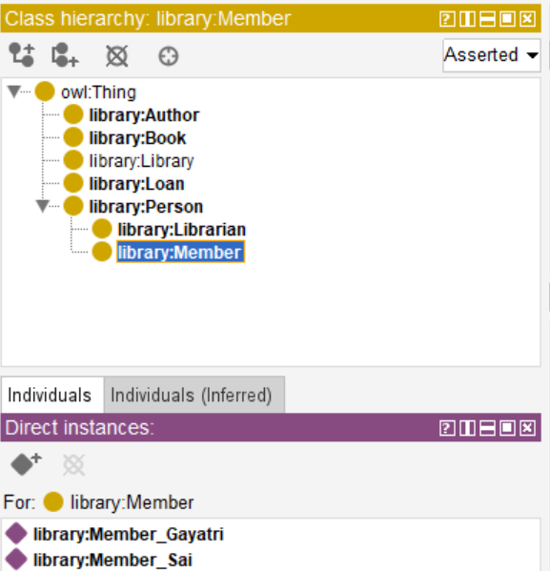
Figure 4 Individuals by class

6. Extension Tasks

6.1 Disjointness
Three axioms of disjointness have been introduced to avoid inconsistency in class membership::
- Member disjoint with Librarian
- Book disjoint with Person
- Author disjoint with Loan
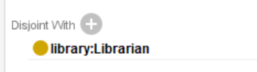
Figure 5 Disjointness Rules of library

6.2 Cardinality Restriction
A cardinality restriction on the Loan class has been specified such that each instance of Loan has precisely one instance of Book associated with it:
loanForBook exactly 1 Book
This reflects the practical constraint of the library system that a loan instance refers to only one book; there should be no instance of a loan without being related to a book.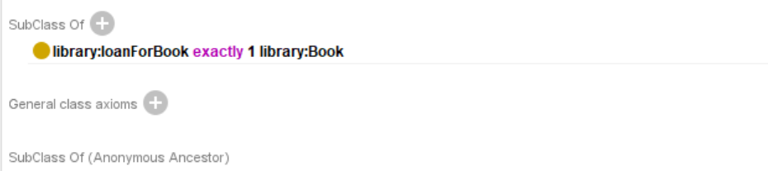
Figure 6 Cardinality Restriction on Loan

6.3 Realistic Class Added – Loan
The Loan class was introduced to enhance the real-world applicability of the ontology. In a real-life scenario, a loan is a separate, traceable item that comes with its metadata, including date of issue and return date, is independent of the Member and Book it relates to, and builds up a history of its own. Introducing the Loan class and modelling it rather than creating the borrowsBook object property between Member and Book enables the ontology to determine the date of borrowing and the date of returning a particular book. This was accomplished by introducing two object properties: hasLoan (from Member to Loan) and loanForBook (from Loan to Book), along with the data properties loanDate and dueDate, and by creating individuals Loan_001 and Loan_002.

7. Reasoning
The HermiT reasoner was run from Reasoner → HermiT → Start Reasoner. Ontology consistency was confirmed by the following outcomes:
- No class names turned red in the class hierarchy panel
- No individuals appeared under owl:Nothing
- All three disjointness axioms were satisfied by the asserted individuals
- The cardinality restriction (loanForBook exactly 1 Book) was verified for both Loan individuals
- Inferred subclass relationships for Member and Librarian under Person were confirmed
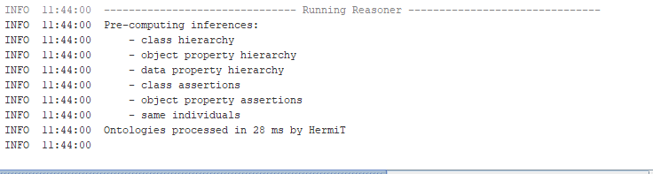
Figure 7 Reasoner Consistency Check of Library

8. SPARQL Queries & Results

Query 1 List All Members
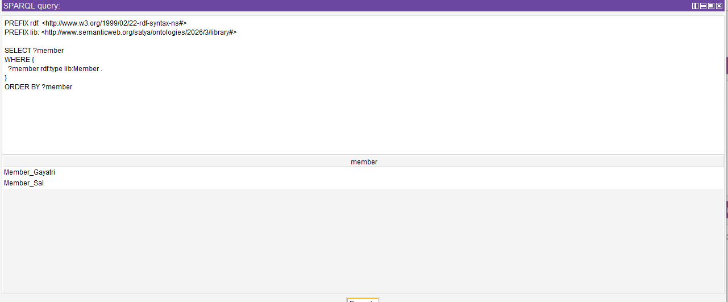
Figure 8 Results of ALL members query

Query 2 Member Names & Membership IDs
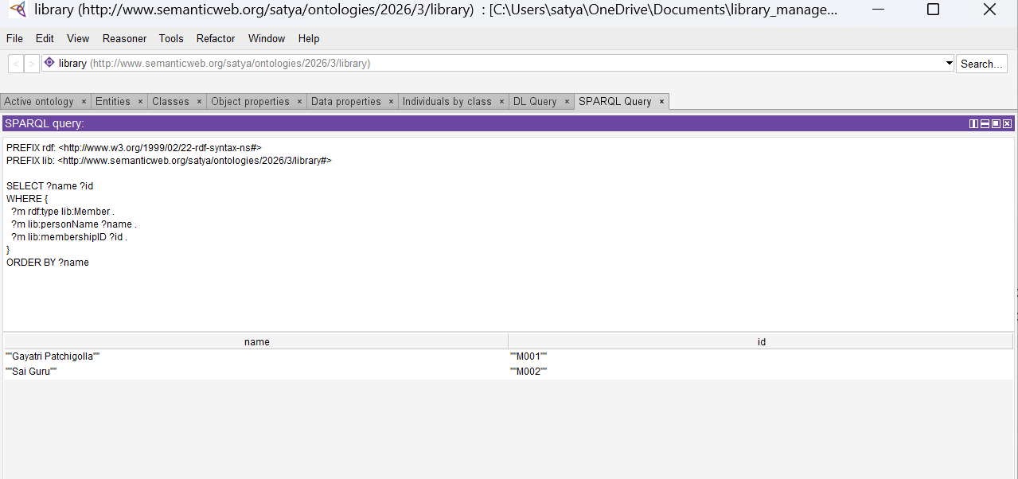
Figure 9 Results of Member Names & IDs Query

Query 3 Which Member Borrowed Which Book
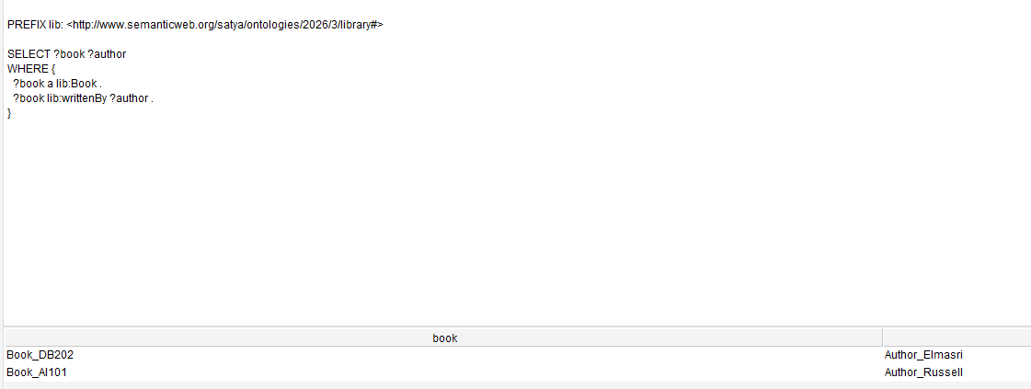
Figure 10 Members & Books Borrowed Query Results

Query 4 Books & Their Authors
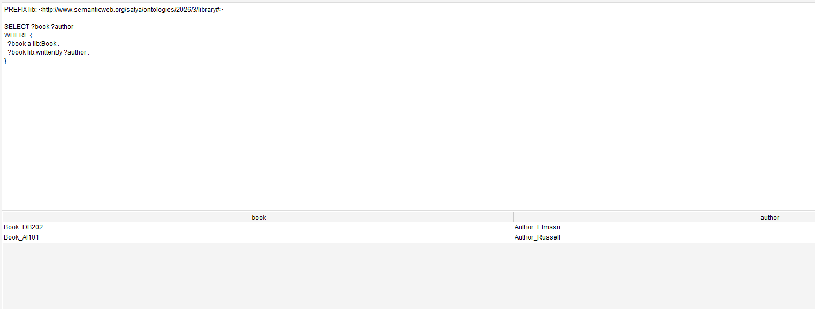
Figure 11 Results of Query Books & Authors

Query 5 Loans Linked to Members & Books
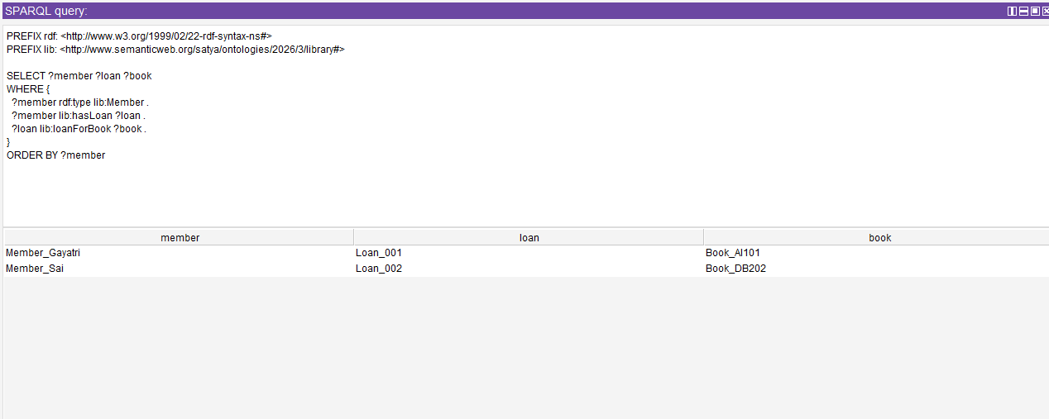
Figure 12 Loans linked to Members & Books query Results

Table 3 Summary Table of Result Query
Q No. | Description | SPARQL Focus | Output
1 | List all Members | Class membership | Member_Gayatri, Member_Sai
2 | Member names and membership IDs | Data property retrieval | Gayatri Patchigolla – M001; Sai Guru – M002
3 | Which member borrowed which book | Object property traversal | Member_Gayatri – Book_AI101; Member_Sai – Book_DB202
4 | Books and their authors | Object property traversal | Book_AI101 – Author_Russell; Book_DB202 – Author_Elmasri
5 | Loans linked to members and books | Multi-class property join | Member_Gayatri – Loan_001 – Book_AI101; Member_Sai – Loan_002 – Book_DB202

9. Linked Data – GitHub Hosting
The ontology file (library_management.rdf) was saved in RDF/XML format and uploaded to a public GitHub repository. GitHub Pages was enabled to provide a stable, dereferenceable
URL: PavanG9391/Library_Management_System_Ontology

10. Ontology-Graph
